FINAL REPORT
On
“Medical Chatbot”



Submitted to
Aravali College Of Engineering & Management
Faridabad

Submitted To: Submitted by:
Ms. Hemlata Rauthan Himanshu (16cse26)
(Assistant Professor in Dept. Sachin kaushik (16cse61)
Of Computer Science) Sunil nain (16cse79)

Session (2016-2020)
Aravali College Of Engineering & Management
Faridabad

ACKNOWLEDGEMENT

I found this golden chance to acknowledge all those people who had blessed, encouraged and supported me technically and morally through all the phases of my project. I take this opportunity to express my profound sense of gratitude. I thank all mighty GOD for giving me this opportunity to express gratitude to all those who helped me in successful completion of this project.
I pay my immense gratitude to Mr Sanjay singh, HOD Dept. of Computer Science for providing help and giving me a chance for showing my skills through continued support and co-operation during the concerned project. I am deeply indebted to staff of Computer Dept., for their sincere co-operation and sparing time to answer questionnaires with their selfless efforts and co-operation because of which I am able to complete this project.
I want to thank Ms. Hemlata Rauthan from the core of my heart to provide the entire infrastructure throughout the course.
I am deeply indebted to my parents who have always been a perennial source of information, encouragement and inspiration for entire education required.

Aravali College Of Engineering & Management
Faridabad

Student Declaration

This is to certify that the project entitled “Medical Chatbot” completed during the 7th semister B.Tech degree is a bona fide piece of research work and all the sources used to complete this project are duly acknowledged. In case the project report, or any part of it, is found to be copied or quoted without reference, I shall be solely held accountable for the repercussions arising there from.

Dated: ………………………. Signature of the Student

Aravali College Of Engineering & Management
Faridabad

Supervisor Certificate

The project entitled “Medical Chatbot” by Himanshu ,Sunil ,Sachin has been completed under my supervision.

.

Dated: ………………………. Signature of the Supervisor

Aravali College Of Engineering & Management
Faridabad

College Certificate

To whom it may concern
The project entitled “Medical Chatbot” submitted by Himanshu ,Sunil ,Sachin in the partial fulfilment for the award of the degree of B.tech is bona fide piece of work completed during 7th semester.

Dated: ………………………. Signature of the H.O.D

INDEX

S.NO. | TABLE OF CONTENTS | PAGE NO.
1 | Introduction to Health Care Window Application | 1
1.1 | System Development Life Cycle. | 2
1.2 | Walk-Through: Features and Functions. | 3
1.3 | Requirement Analysis. | 6
1.4 | Feasibility Study. | 8
2 | System Analysis. | 10
3 | System Design. | 11
3.1 | Hardware and Software Requirements. | 16
3.2 | Technical Requirements | 17
3.3 | Technology to be used.
 | - Front End. | 19
 | - Back End. | 22
3.4 | DESIGN.
 | - Software Model Followed. | 24
 | - Database Tables | 27
 | - ER Diagram. | 40
4 | CODING. | 41-51
 | - Design View.
 | - Code View.
5 | SCREENSHOTS. | 51-62
6 | Testing. | 63
7 | Implementation. | 67
8 | Maintenance. | 70
9 | Bibliography. | 71

Introduction

THE PURPOSE OF THIS PROJECT TO PROVIDE admin has to collect the patients medical history of records and filter it appropriately by applying data preprocessing techniques. Once the data comes into the structured shape it can then be fed into the relational database structure of MS Excel file. The admin also needs to monitor the predictions and replies of the model to ascertain quality.

Admin’s functionalities are to Collecting the appropriate medical records of the patients, handle missing values, handling categorical values,Creating sparse matrix representation, Feeding data to the autonomous pipeline for predictions, selecting and training an appropriate machine learning algorithm.

VISITOR can perform the basic task of visitor is to access the chat bot from the front end and reply to its queries with a binary response (Yes/No). The visitor will be shown a confidence interval related to a certain prognosis which needs to be further investigated and experimented with for better results. The visitor can also contribute with the help of the admin to add new symptoms and diagnosis records to the database of medical history.

THE WINDOW APPLICATION PURPOSE IS TO ALLOW THESE CLIENTS AN EASY MEDIUM IN WHICH TO CHECK THEIR HEALTH ISSUES AND PROVIDE BEST DOCTER ACCORDING TO THEIR SYMTOMS.

The first step is to start their procedure, then one by one all the symtoms come in clients screen. They will have to reply with yes or no answer.

Once a problem will found then they will have to click yes, then patient can see their problem in screen.

The Best Part is that it will provide docter’s information like Docter name and his/her website link. So that one can easily find their docter with don’t face any type of problem, and start their treatment.

This will prepare with the help of chatbot so that one can even check their problem at any time.You have to just reply with clicking of button Yes or No.

SDLC:

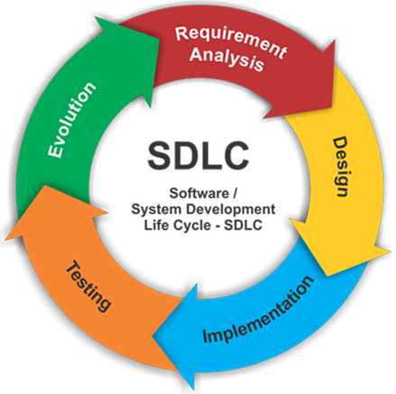

WALK-THROUGH:

REPRESENTATIVE TKINTER FEATURES AND FUNCTIONS:

- TKINTER: Tkinter is the standard GUI library for Python. Python when combined with Tkinter provides a fast and easy way to create GUI applications. Tkinter provides a powerful object-oriented interface to the Tk GUI toolkit.
Creating a GUI application using Tkinter is an easy task. All you need to do is perform the following steps −
- Import the Tkinter module.
- Create the GUI application main window.
- Add one or more of the above-mentioned widgets to the GUI application.
- Enter the main event loop to take action against each event triggered by the user.

Tkinter Widgets:

Widgets are something like elements in the HTML. You will find different types of widgets to the different types of elements in the Tkinter.
Let's see the brief introduction to all of these widgets in the Tkinter.
- Button:- Button widget is used to place the buttons in the tkinter.
- Canvas:- Canvas is used to draw shapes in your GUI.
- Checkbutton:- Checkbutton is used to create the check buttons in your application. You can select more than one option at a time.
- Entry:- Entry widget is used to create input fields in the GUI.
- Frame:- Frame is used as containers in the tkinter.
- Label:- Label is used to create a single line widgets like text, images, etc..,
- Menu:- Menu is used to create menus in the GUI.

- LOGIN MENU: A login is a set of credentials used to authenticate a user. Most often, these consist of a username and password. However, a login may include other information, such as a PIN number, passcode, or passphrase. Some logins require a biometric identifier, such as a fingerprint or retina scan.
Logins are used by websites, computer applications, and mobile apps. They are a security measure designed to prevent unauthorized access to confidential data. When a login fails (i.e, the username and password combination does not match a user account), the user is disallowed access. Many systems block users from even trying to log in after multiple failed login attempts.
Examples of logins include:
- Operating System login – Windows and Mac systems can be configured to require a login in order to use the computer after it is turned on or woken from sleep mode. A login may also be required to install software or modify system files.
- Website login – Webmail interfaces, financial websites, and many other sites require a username and password in order to access account information.
- App store login – App stores like Google Play and Apple's App Store require a login to download mobile apps, music, and other files.
- FTP login – file transfer programs often require a login in order to browse, send, and receive files from an FTP server.
- Router login – Wired and wireless routers typically require an administrator login to modify the settings.

At a basic level, logins make user accounts possible. Most systems require unique usernames, which ensures every user's login is different. On a more advanced level, logins provide a security layer between unsecured and secure activity. Once a user logs in to a secure website, for example, all data transfers are typically encrypted. This prevents other systems from viewing or recording the data transferred from the server.

- SIGNUP MENU : The Sign up module has been developed using the Tkinter GUI framework written in Python. It facilitates the user to save his/her data into the Oracle database. The signup form will be explicitly used to insert the records of doctors who will be using the disease prediction system. The doctors data has been scraped from Internet for research purposes. The signup module opens the prediction window for a legitimate user and displays a message box in case of failed authentication.

- PREDICTION WINDOW :

The prediction window can be accessed only by legitimate doctors saved in our portal. It provides a start button to start the analysis process of the symptoms. The prediction window poses questions in the form of symptoms to the user and expects a binary response which can be provided by pressing the yes or no buttons. The system records the entries of the user and finally gives a prediction. It also describes the symptoms inserted along with the symptoms expected. The model guesses the disease associated with the following symptoms and then gives a specialized name of doctor to consult in the aforementioned department. The prediction window also displays a dynamic link to book an appointment of the specialized doctor suggested by the model.

- SYMPTOMS WINDOW :

The Symptoms window is created or called at run time when the user is inserting the symptoms into the model. When the model is satisfied with an appropriate number of inputs. It then generates a response in the form of the predicted disease, symptoms given, confidence interval and the recommendation for the doctor to visit next. The symptoms window also provides a link to book an appointment with the concerned doctor which can copy and pasted into the browser by the user for further operations.

Requirement Analysis:

Requirement Analysis is a software engineering task that bridges the gap between system level software allocation and software design. It provides the system engineer to specify software function and performance indicate software’s interface with the other system elements and establish constraints that software must meet.
The basic aim of this stage is to obtain a clear picture of the needs and requirements of the end-user and also the organization. Analysis involves interaction between the clients and the analysis. Usually analysts research a problem from any questions asked and reading existing documents. The analysts have to uncover the real needs of the user even if they don’t know them clearly. During analysis it is essential that a complete and consistent set of specifications emerge for the system. Here it is essential to resolve the contradictions that could emerge from information got from various parties.
This is essential to ensure that the final specifications are consistent.
It may be divided into 5 areas of effort.
- Problem recognition
- Evaluation and synthesis
- Modelling
- Specification
- Review

Each Requirement analysis method has a unique point of view. However all analysis methods are related by a set of operational principles. They are
- The information domain of the problem must be represented and understood.

- The functions that the software is to perform must be defined.

- The behaviour of the software as a consequence of external events must be defined.

- The models that depict information function and behavior must be partitioned in a hierarchical or layered fashion.

- The analysis process must move from essential information to implementation detail.

REQUIREMENTS SPECIFICATION

Specification Principles:

Software Requirements Specification plays an important role in creating quality software solutions. Specification is basically a representation process. Requirements are represented in a manner that ultimately leads to successful software implementation.
Requirements may be specified in a variety of ways. However there are some guidelines worth following: -
- Representation format and content should be relevant to the problem
- Information contained within the specification should be nested
- Diagrams and other notational forms should be restricted in number and consistent in use.
- Representations should be revisable.

Software Requirements Specifications:

The software requirements specification is produced at the culmination of the analysis task. The function and performance allocated to the software as a part of system engineering are refined by establishing a complete information description, a detailed functional and behavioural description, and indication of performance requirements and design constraints, appropriate validation criteria and other data pertinent to requirements.

FEASIBILITY STUDY

An initial investigation culminates in a proposal that determines whether an alternative system is feasible. It is always necessary to carry out the feasibility study for the development of new project system. The most successful system projects are not necessarily the biggest one rather that truly fulfils user expectations. If the feasibility study is to serve as a decision element, it must answer the following questions:-

- Is there any new and better way to do the job that solves the purpose?
- What are the costs and savings of the alternatives?
- Are there any legal restrictions imposed by the government or any other regulatory body?
- Is the proposed solution economically feasible?
- Does there exists any bottleneck that may turn the process of development futile exercise?
- What is recommended?

I, thereby keeping in mind the above mentioned guidelines carried out a brief study for the project. This study can be categorized under as:

  - Economical feasibility
  - Legal feasibility
  - Technical feasibility
  - Operational feasibility
  - Behavioral feasibility

Economical feasibility
Economic feasibility is most frequently used for providing the effectiveness of the system. The most commonly known as cost/benefit analysis, the procedure is to determine the benefits and savings that are expected from the proposed and compare them with the cost incurred in the current/existing scenario. Before the development of my system:
- Inefficient use of the internet resource was done. No proper schedules were implemented so as provide the internet resource at specified timings. Most of the students were found to be accessing internet during there language practical timings. This has been overcome by implementing user group management. This has lead to an efficient use of the resource.

Legal feasibility
The development of proposed system is legally feasible because there are no governments or organizational restrictions imposed on it. The software’s that will be used to make the project are open-source and free to use. Hence, the project is legally feasible.

Technical feasibility
Technical feasibility centers on existing computer system (hardware and software) etc. and to what extent it can support the proposed edition. It is technically feasible, since the whole system is designed into the technologies like Python which are the most recent technologies to develop windows based systems.

Operational feasibility
Once it is determined that system is both technically and economically feasible then it has to be seen if it is operationally feasible. Operational feasibility refers to projecting whether the system will operate and be used once it is installed.
The proposed system is operationally feasible, as there no need for the faculty to keep a check on use of internet at the time of language practical’s. There no need to keep a manual eye on the behavior of client on the internet. Site blocking, service blocking (FTP/HTTP) and content filtering features of proposed system cater to this very task.
We have designed front end by getting the information from the end user, which help us in designing the GUI according to the end user’s requirements. The end users can easily understand and expand it in the future.
As the faculty members expressed the need for an improved system, they put in all efforts to see that it becomes feasible.

Behavioural feasibility

People are inherently resistant to change, and computers have been known to facilitate change. An estimate should be made of how strong a reaction the user staff is likely to have toward the development of a computerized system. It is common knowledge that computer installation has something to do with turnover, transfers, retraining, and the charges in employee job status. Therefore, it is understandable that the introduction of a candidate system requires special efforts to educate, sell, and train the staff on new ways of conducting business.

SYSTEM ANALYSIS:

This section addresses security considerations unique to the second SDLC phase. Key security activities for this phase include:
- Conduct the risk assessment and use the results to supplement the baseline security controls;
- Analyze security requirements;
- Perform functional and security testing;
- Prepare initial documents for system certification and accreditation;
Although this section presents the information security components in a sequential top-down manner, the order of completion is not necessarily fixed. Security analysis of complex systems will need to be iterated until consistency and completeness is achieved.
The analysis phase involves gathering requirements for the system. At this stage, business needs are studied with the intention of making business processes more efficient. The system analysis phase focuses on what the system will do in an effort that views all stakeholders, as viable sources of information. In the analysis phase, a significant amount of time is spent talking with stakeholders and reviewing the stakeholder’s input. Common stakeholders for IT projects are:

- Architecture office
- Testing & certification office
- Records management team
- Application support group

Once stakeholders have been recognized, the gathering and analysis of the requirements can begin. Requirement gathering must be related to business needs or opportunities. Requirement analysis involves capturing requirements and analyzing requirements. Capturing requirements is communicating with stakeholders to agree on what the requirements are. Analyzing requirements is using standard tools to produce a baseline of the requirements. Once the stakeholders concur on the requirements, the baseline is created and becomes the formal requirement source.

Within this analysis phase, the analyst is discovering and fact finding. Along with meeting with stakeholders, the analyst must meet with end users to understand what the user's needs are and to learn about problems that affect the current system in order to assist with designing a new and more efficient system. There are several activities that must occur within the analysis phase:

- Gather Information
- Define the new system's requirements
- Build prototypes for the new system
- Prioritize requirements
- Evaluate alternatives
- Meet with management to discuss new options

System Design:

System design is the most creative phase of the system development. The term describes a final system and the process by which it is developed. The question in system design is:
How the problem is to be solved?

A systematic method has to achieve the beneficial results at the end. It involves starting with a vague idea and developing it into a series of steps. The series of steps for successful system design are:

- First step is to study the problem completely because we should know the goal. We should see what kind of output we require and what king of input we give so that we can get desired result. We should see what kind of program should be developed to reach the final goal.

- Then we write individual programs, which later on joining solve the specified problem.

- Then we test these programs and make necessary corrections to achieve target of the programs.

While designing we had to consider all the requirements of the USERS to make such an interface which makes the communication easy and accurate. The interface is designed to provide the efficient and clear information of each and every detail of application.

- DEFAULT PAGE:
The first webpage designed is the Default Page. This page divides into two parts that is :-
- LOGIN
- REGISTER

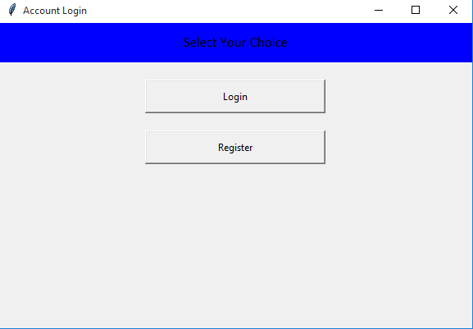

LOGIN WINDOW:

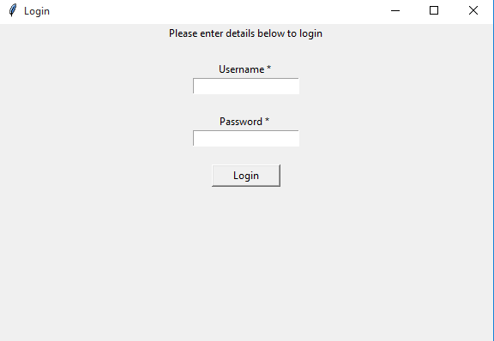

SIGNUP WINDOW:

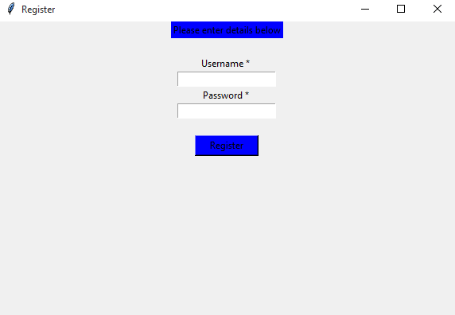

MAIN WINDOW:-

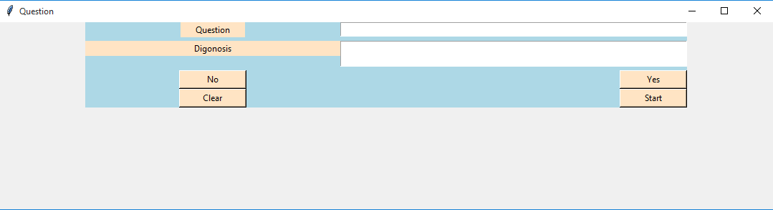

Hardware & Software Requirements:

- HARDWARE REQUIREMENTS:
- Intel Core(TM)2 dual core and above
- 240 GB HD
- Minimum 2 GB RAM
- Standard USB Keyboard and Mouse
- Window-7 or above

- SOFTWARE REQUIREMENTS:
- Operating System: Windows 7 or Above
- Front End Programming : - TKinter
- Back End Database : -MS EXCEL
- Modules Used:- pymysql, Tkinter,Chatbot

Technical Requirements:
The main thing is that, irrespective of its functions and the tasks it is entrusted with, window application should fully fit the spirit and the principles of the company. That is why you should be very serious when deciding to develop a window application. And in order to get exactly what you need in the end of the development, you need to clearly define requirements.
So, requirements specification (RS) is a code of all window application requirements. RS is an integral part of agreement between a client and developers: It should contain description of all stages of window application development, the core and tasks of development works, functional elements tasks; programming rules, constraints and testing and project estimation methods should be defined. RS presence will make work of both parties easier and will allow testing the end result of the work.
That is why attention and scrupulosity are necessary for the RS working out.
So, RS should include the following parts:
1. General information on the project.
In this part, time-frame of site development is defined; information on project financing is given; order of providing with work results is defined, etc.
2. Window Application purpose and goals.
In this part, Application aims are defined, kind of activity which should be realized via window application is described, etc.
3. Site characteristics.
In this part of the RS site functioning and operation conditions are described, constraints and limitations (for example, on volume of information stored in the database) are determined, etc.
4. Window Application design requirements.
Application style and design requirements are described. Elements which should present on every site page are named.

5. Window Application navigation structure.
We recommend you to describe application navigation structure. This will help client to see the content structure and to prepare it correctly later on.
6. Window Application functionality requirements.
In this part, requirements to the site as a whole and requirements to site functions and tasks are described.
7. Content requirements.
These requirements can be set only if developers take responsibility for site content development. If you develop the content yourself, this part of RS is irrelevant.
8. Structure and content of application development work.
In this part of the RS work stages and phases, every stage completion time-frames, certain work carrying-out instructions are listed, etc.
9. Order of control and work acceptance by client.
Work acceptance requirements, kinds and methods of testing are described.

Technology to be used:

Front End:

TKINTER:
Tkinter is an inbuilt Python module used to create simple GUI apps. It is the most commonly used module for GUI apps in the Python.

Tkinter Widgets:
Widgets are something like elements in the HTML. You will find different types of widgets to the different types of elements in the Tkinter.
Let's see the brief introduction to all of these widgets in the Tkinter.
- Button:- Button widget is used to place the buttons in the tkinter.
- Canvas:- Canvas is used to draw shapes in your GUI.
- Checkbutton:- Checkbutton is used to create the check buttons in your application. You can select more than one option at a time.
- Entry:- Entry widget is used to create input fields in the GUI.
- Frame:- Frame is used as containers in the tkinter.
- Label:- Label is used to create a single line widgets like text, images, etc..,
- Menu:- Menu is used to create menus in the GUI.

Geometry Management
All widgets in the tkinter will have some geometry measurements. These measurements give you to organize the widgets and their parent frames, windows, etc..,
Tkinter has the following three Geometry Manager classes.
- pack():- It organizes the widgets in the block, which mean it occupies the entire available width. It's a standard method to show the widgets in the window.
- grid():- It organizes the widgets in table-like structure.
- place():- It's used to place the widgets at a specific position you want.

Features :
- Easy
- Expressive
- Free and open source
- High Level
- Portable
- Interpreted
- Object Oriented
- Extensible
- Embeddable
- Large Standard Library

1. Easy: When we say the word ‘easy’, we mean it in different contexts.
a. Easy to code: As we have seen in earlier lessons, Python is very easy to code. Compared to other popular languages like Java and C++, it is easier to code in Python. Anyone can learn python syntax in just a few hours. Though sure, mastering Python requires learning about all its advanced concepts and packages and modules. That takes time. Thus, it is programmer-friendly.
b. Easy to read : Being a high-level language, Python code is quite like English. Looking at it, you can tell what the code is supposed to do. Also, since it is dynamically-typed, it mandates indentation. This aids readability.
2. Expressive : First, let’s learn about expressiveness. Suppose we have two languages A and B, and all programs that can be made in A can be made in B using local transformations. However, there are some programs that can be made in B, but not in A, using local transformations. Then, B is said to be more expressive than A. Python provides us with a myriad of constructs that help us focus on the solution rather than on the syntax. This is one of the outstanding python features that tells you why you should learn Python.

- 3. Free and Open-Source: Firstly, Python is freely available. Secondly, it is open-source. This means that its source code is available to the public. You can download it, change it, use it, and distribute it. This is called FLOSS(Free/Libre and Open Source Software). As the Python community, we’re all headed toward one goal- an ever-bettering Python
- 4. High- Level : As we discussed in point 2b, it is a high-level language. This means that as programmers, we don’t need to remember the system architecture. Nor do we need to manage the memory. This makes it more programmer-friendly and is 1 of the key python features.
- 5. Portable : Let’s assume you’ve written a Python code for your Windows machine. Now, if you want to run it on a Mac, you don’t need to make changes to it for the same. In other words, you can take one code and run it on any machine, there is no need to write different code for different machines. This makes Python a portable language. However, you must avoid any system-dependent features in this case.
- 6. Interpreted : If you’re any familiar with languages like C++ or Java, you must first compile it, and then run it. But in Python, there is no need to compile it. Internally, its source code is converted into an immediate form called byte code. So, all you need to do is to run your Python code without worrying about linking to libraries, and a few other things.
By interpreted, we mean the source code is executed line by line, and not all at once. Because of this, it is easier to debug your code. Also, interpreting makes it just slightly slower than Java, but that does not matter compared to the benefits it has to offer.
7. Extensible : If needed, you can write some of your Python code in other languages like C++. This makes Python an extensible language, meaning that it can be extended to other languages.

8. Embeddable : We just saw that we can put code in other languages in our Python source code. However, it is also possible to put our Python code in a source code in a different language like C++. This allows us to integrate scripting capabilities into our program of the other language.

9. Large Standard Library : Python downloads with a large library that you can use so you don’t have to write your own code for every single thing. There are libraries for regular expressions, documentation-generation, unit-testing, web browsers, threading, databases, CGI, email, image manipulation, and a lot of other functionality.

Back End:

MICROSOFT EXCEL:
Microsoft Excel is a spreadsheet program that is used to record and analyse numerical data. Think of a spreadsheet as a collection of columns and rows that form a table. Alphabetical letters are usually assigned to columns and numbers are usually assigned to rows. The point where a column and a row meet is called a cell. The address of a cell is given by the letter representing the column and the number representing a row.
Where can I get Microsoft Excel?
There are number of ways in which you can get Microsoft Excel. You can buy it from a hardware computer shop that also sells software. Microsoft Excel is part of the Microsoft Office suite of programs. Alternatively, you can download it from the Microsoft website but you will have to buy the license key.

Understanding the Ribbon
The ribbon provides shortcuts to commands in Excel. A command is an action that the user performs. An example of a command is creating a new document, printing a documenting, etc. The image below shows the ribbon used in Excel 2013.
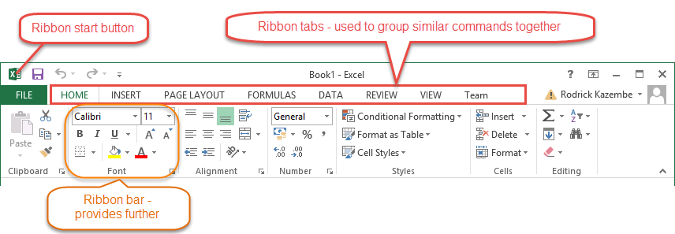

Ribbon components explained
Ribbon start button - It is used to access commands i.e. creating new documents, saving existing work, printing, accessing the options for customizing Excel, etc.
Ribbon tabs – The tabs are used to group similar commands together. The home tab is used for basic commands such as formatting the data to make it more presentable, sorting and finding specific data within the spreadsheet.
Ribbon bar – The bars are used to group similar commands together. As an example, the Alignment ribbon bar is used to group all the commands that are used to align data together.
A worksheet is a collection of rows and columns. When a row and a column meet, they form a cell. Cells are used to record data. Each cell is uniquely identified using a cell address. Columns are usually labelled with letters while rows are usually numbers.
A workbook is a collection of worksheets. By default, a workbook has three cells in Excel. You can delete or add more sheets to suit your requirements. By default, the sheets are named Sheet1, Sheet2 and so on and so forth. You can rename the sheet names to more meaningful names i.e. Daily Expenses, Monthly Budget, etc.

SUMMARY:-
- Microsoft Excel is a powerful spreadsheet program used to record, manipulate, store numeric data and it can be customized to match your preferences
- The ribbon is used to access various commands in Excel
- The options dialogue window allows you to customize a number of items i.e. the ribbon, formulas, proofing, save, etc.

Software Model Followed:
Waterfall Model
The waterfall model is a sequential design process, often used in software development processes, in which progress is seen as flowing steadily downwards (like a waterfall) through the phases of Conception, Initiation, Analysis, Design, Coding, Testing, Implementation, and Maintenance.
PROBLEM DEFINATION

ANALYSIS

DESIGN

CODING

TESTING

IMPLEMENTATION

MAINTENANCE

PHASES OF SYSTEM DEVELOPMENT

Problem Definition and Description
This deals with preparing a concise statement of the problem to be solved. Here is a detail description of the present system and an overview of the system is stated.

Analysis
Analysis is the process diagnosing situation, done with a defiant aim, with the boundaries of the system kept in mind to produce a report based on the findings. Analysis is a fact finding technique where system requirement specifications, feasibility analysis and cost benefit analysis are carried out.

Design
Design is concerned with identifying the software components, specifying relationship among components, specifying software structure, maintaining a record of design decisions and providing a blueprint for the implementation phase.

Coding
Coding performs the translations of the design representations into an artificial language resulting in instructions that can be executed by the computer, it thus involves developing computer programs that meet the system specifications of the design stage.

Testing
Testing process focuses on the logical internals of the software, ensuring that all statements have been tested on the functional externals that is conducting tests using various tests data to uncover errors and ensure that defined input will produce actual result that agree with required results.

Implementation
Implementation is a process that includes all those activities that take place to convert an old system to a new system. The new system may be totally new system replacing the existing or it may be the major modification to the existing system.

Maintenance
Software will undergo changes after it has been delivered to the customer. Change will occur because of many reasons such as: errors have been encountered, the user requires functional or performance enhancements, following the acceptance by customer. The software is released for production works and enters the maintenance reapplies each of the capabilities, adaptations of the software to the new processing environments to the correction of the software bugs.

Advantages
The advantage of waterfall development is that it allows for departmentalization and managerial control. A schedule can be set with deadlines for each stage of development and a product can proceed through the development process like a car in a carwash, and theoretically, be delivered on time. Development moves from concept, through design, implementation, testing, installation, troubleshooting, and ends up at operation and maintenance. Each phase of development proceeds in strict order, without any overlapping or iterative steps.

Disadvantages
The disadvantage of waterfall development is that it does not allow for much reflection or revision. Once an application is in the testing stage, it is very difficult to go back and change something that was not well-thought out in the concept stage. Alternatives to the waterfall model include joint application development (JAD), rapid application development (RAD), synch and stabilize, build and fix, and the spiral model.

DATABASE TABLES:

It has Four Columns:-
- Name
- Type
- Size
- Value

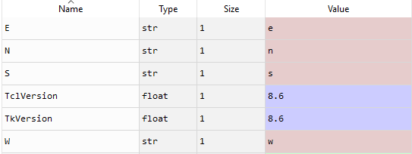

X_ DATASET:- It contain number of input given by users.

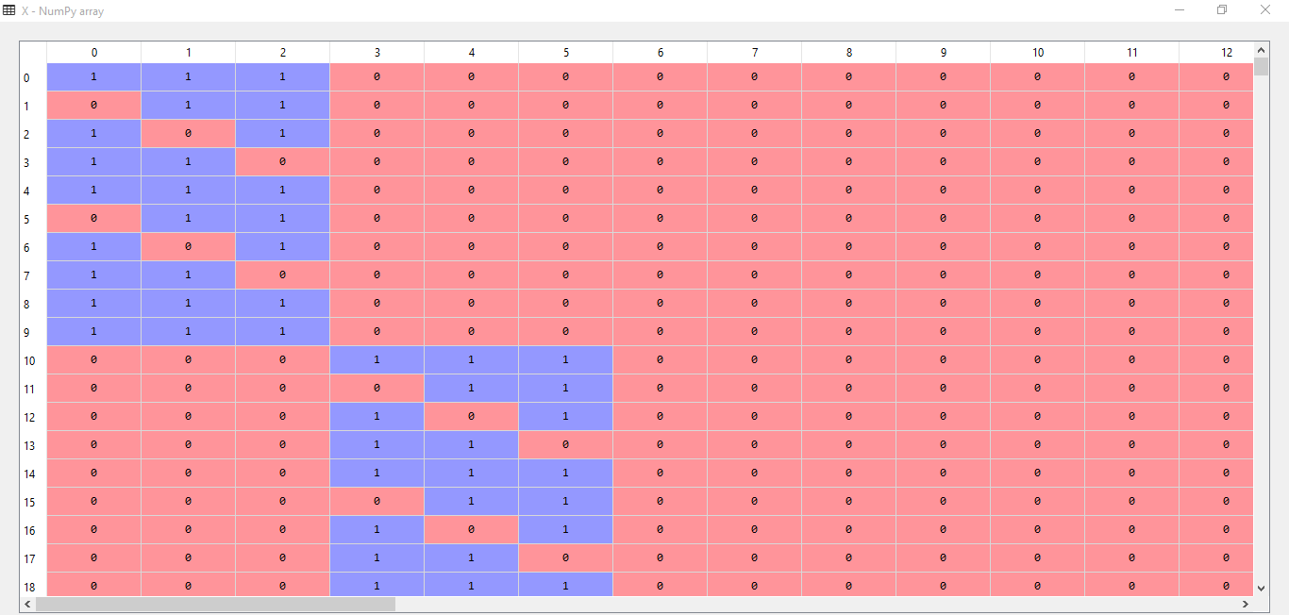

X_TEST DATASET:- It divides the x just to check if our output will be correct or not.

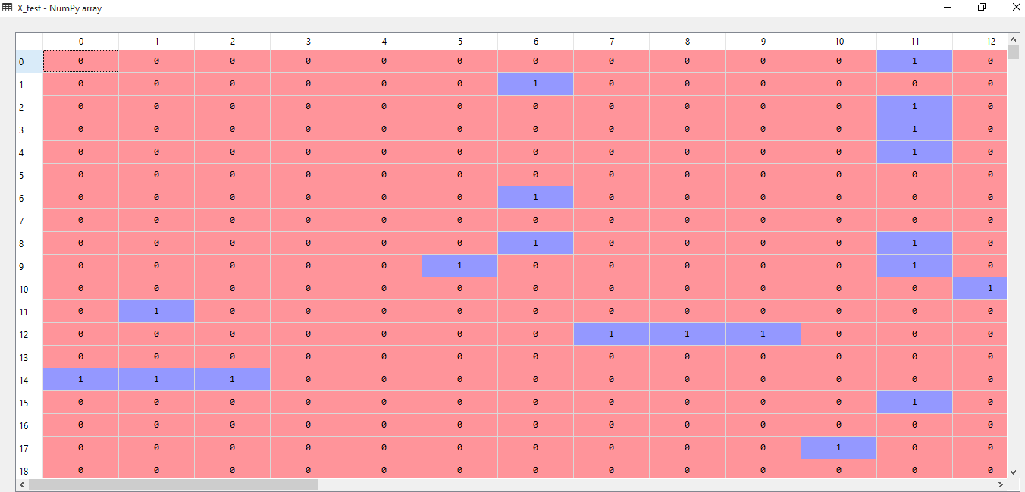

X_TRAIN DATASET:- It also divide x dataset into another part called as training set.

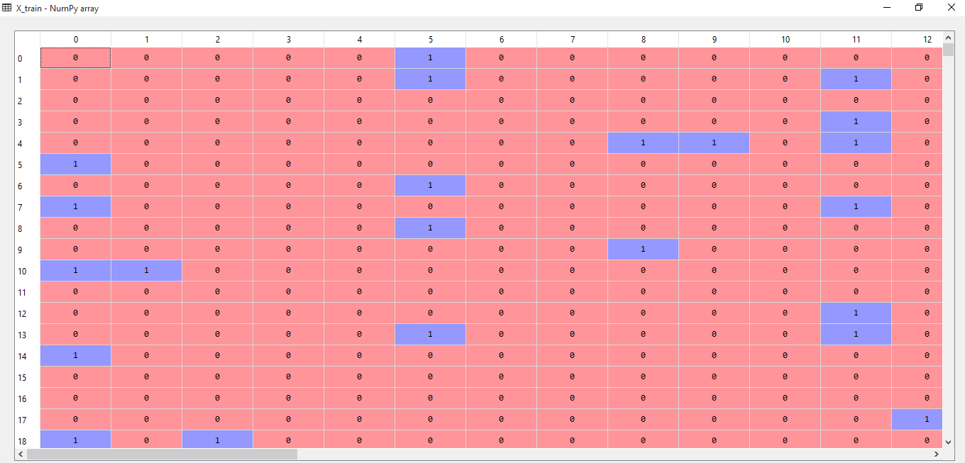

DIMENSIONALIY_REDUCTION:- To avoid repeat value and contain unique values.

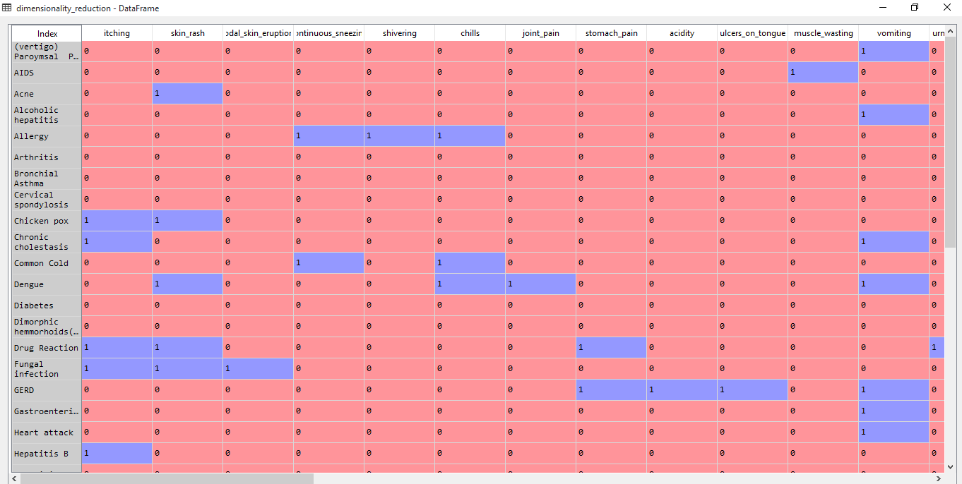

DISEASES:- Number of Diseases.

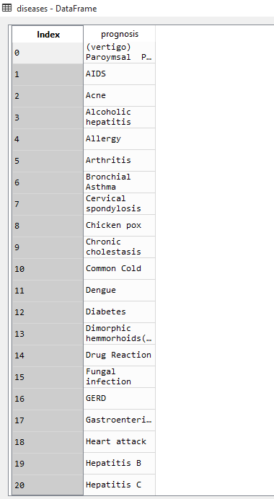

DOCTER DATASET:- It will provide Docter name with its link where one can visit his/her site and also tell problem. It contain multiple rows and three columns.

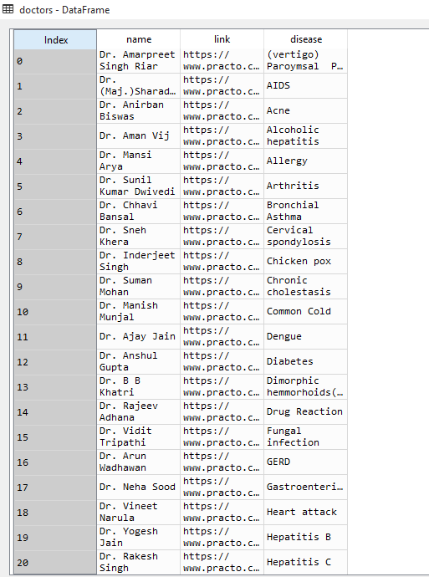

DOCTER DATASET:- It contain multiple rows and only Two columns which is Docters name and its Description.

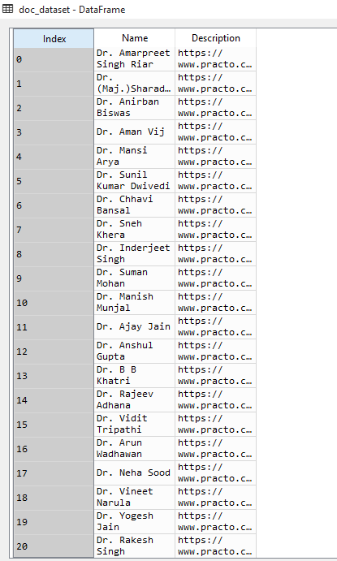

TRAINING_DATASET:-

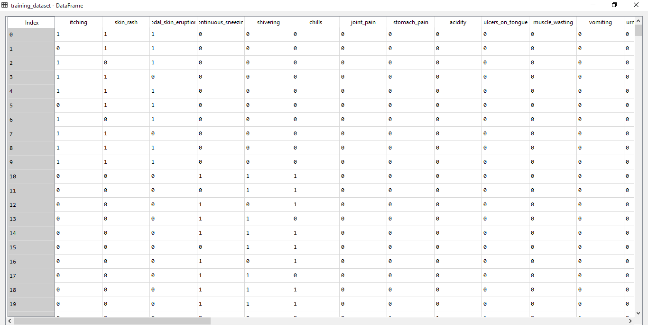

TEST DATASET:-

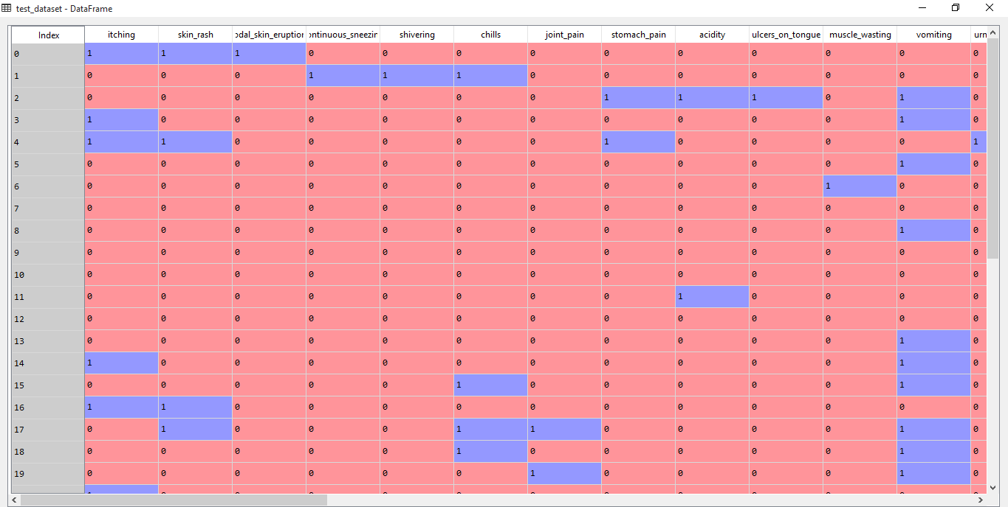

Y _TEST DATASET:- It contain output only for test dataset.

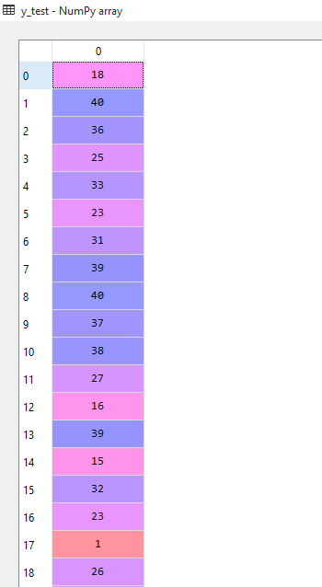

Y_TRAINING DATASET:-

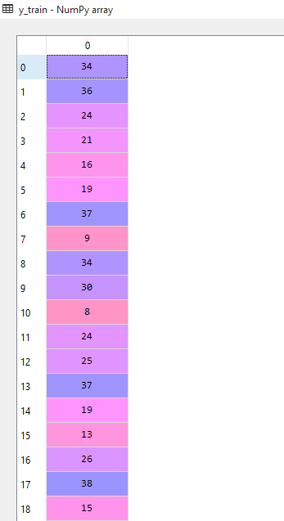

ER Diagram

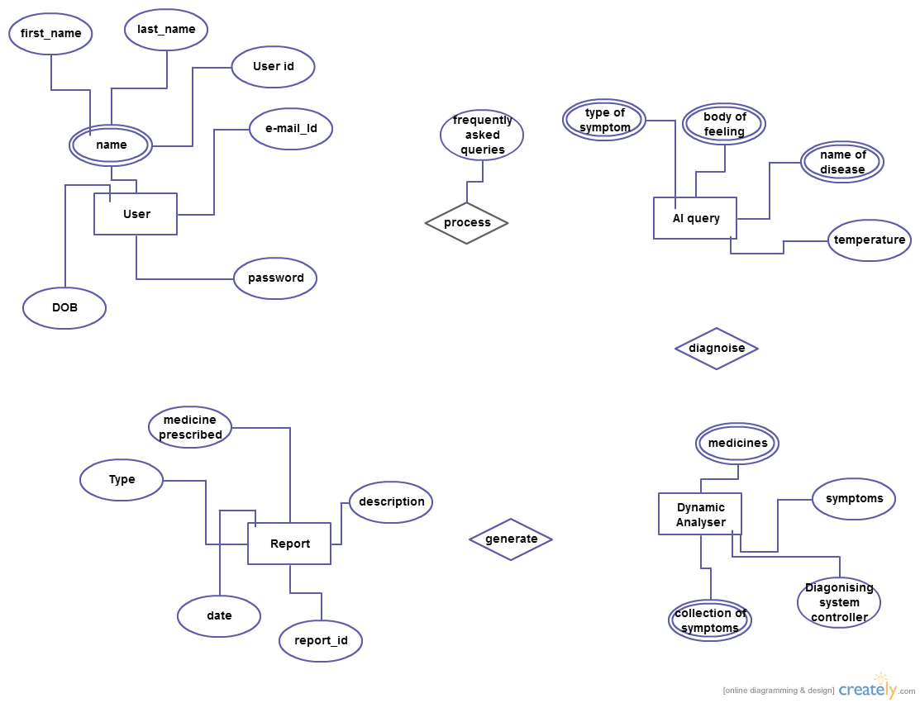

CODING

BASED ON TKINTER

######## A Healthcare Domain Chatbot to simulate the predictions of a General Physician ########
######## A pragmatic Approach for Diagnosis ############

# Importing the libraries
import numpy as np
import pandas as pd

# Importing the dataset
training_dataset = pd.read_csv('Training.csv')
test_dataset = pd.read_csv('Testing.csv')

# Slicing and Dicing the dataset to separate features from predictions
X = training_dataset.iloc[:, 0:132].values
Y = training_dataset.iloc[:, -1].values

# Dimensionality Reduction for removing redundancies
dimensionality_reduction = training_dataset.groupby(training_dataset['prognosis']).max()

# Encoding String values to integer constants
from sklearn.preprocessing import LabelEncoder
labelencoder = LabelEncoder()
y = labelencoder.fit_transform(Y)

# Splitting the dataset into training set and test set
from sklearn.model_selection import train_test_split
X_train, X_test, y_train, y_test = train_test_split(X, y, test_size = 0.25, random_state = 0)

# Implementing the Decision Tree Classifier
from sklearn.tree import DecisionTreeClassifier
classifier = DecisionTreeClassifier()
classifier.fit(X_train, y_train)

# Saving the information of columns
cols = training_dataset.columns
cols = cols[:-1]

# Checking the Important features
importances = classifier.feature_importances_
indices = np.argsort(importances)[::-1]
features = cols

# Implementing the Visual Tree
from sklearn.tree import _tree

# Method to simulate the working of a Chatbot by extracting and formulating questions
def print_disease(node):
#print(node)
node = node[0]
#print(len(node))
val = node.nonzero()
#print(val)
disease = labelencoder.inverse_transform(val[0])
return disease
def recurse(node, depth):
global val,ans
global tree_,feature_name,symptoms_present
indent = " " * depth
if tree_.feature[node] != _tree.TREE_UNDEFINED:
name = feature_name[node]
threshold = tree_.threshold[node]
yield name + " ?"
# ans = input()
ans = ans.lower()
if ans == 'yes':
val = 1
else:
val = 0
if val <= threshold:
yield from recurse(tree_.children_left[node], depth + 1)
else:
symptoms_present.append(name)
yield from recurse(tree_.children_right[node], depth + 1)
else:
strData=""
present_disease = print_disease(tree_.value[node])
# print( "You may have " + present_disease )
# print()
strData+="You may have " + present_disease
red_cols = dimensionality_reduction.columns
symptoms_given = red_cols[dimensionality_reduction.loc[present_disease].values[0].nonzero()]
# print("symptoms present " + str(list(symptoms_present)))
# print()
strData+="symptoms present " + str(list(symptoms_present))
# print("symptoms given " + str(list(symptoms_given)) )
# print()
strData+="symptoms given " + str(list(symptoms_given))
confidence_level = (1.0*len(symptoms_present))/len(symptoms_given)
# print("confidence level is " + str(confidence_level))
# print()
strData+="confidence level is " + str(confidence_level)
# print('The model suggests:')
# print()
# strData+='The model suggests:'
# row = doctors[doctors['disease'] == present_disease[0]]
# print('Consult ', str(row['name'].values))
# print()
# strData+='Consult ', str(row['name'].values)+"\n"
# print('Visit ', str(row['link'].values))
#print(present_disease[0])

# strData+='Visit ', str(row['link'].values)+"\n"
yield strData

def tree_to_code(tree, feature_names):
global tree_,feature_name,symptoms_present
tree_ = tree.tree_
#print(tree_)
feature_name = [
feature_names[i] if i != _tree.TREE_UNDEFINED else "undefined!"
for i in tree_.feature
]
#print("def tree({}):".format(", ".join(feature_names)))
symptoms_present = []
# recurse(0, 1)

def execute_bot():
# print("Please reply with yes/Yes or no/No for the following symptoms")
tree_to_code(classifier,cols)

# This section of code to be run after scraping the data

doc_dataset = pd.read_csv('doctors_dataset.csv', names = ['Name', 'Description'])

diseases = dimensionality_reduction.index
diseases = pd.DataFrame(diseases)

doctors = pd.DataFrame()
doctors['name'] = np.nan
doctors['link'] = np.nan
doctors['disease'] = np.nan

doctors['disease'] = diseases['prognosis']

doctors['name'] = doc_dataset['Name']
doctors['link'] = doc_dataset['Description']

record = doctors[doctors['disease'] == 'AIDS']
record['name']
record['link']

# Execute the bot and see it in Action
#execute_bot()

from tkinter import *
from tkinter import messagebox
import os
class QuestionDigonosis(Frame):
objIter=None
def __init__(self,master=None):
master.title("Question")
# root.iconbitmap("")
master.minsize(700,350)
super().__init__(master=master)
self["bg"]="light blue"
self.createWidget()
self.iterObj=None

def createWidget(self):
self.lblQuestion=Label(self,text="Question",width=12,bg="bisque")
self.lblQuestion.grid(row=0,column=0,rowspan=4)

self.lblDigonosis = Label(self, text="Digonosis",width=12,bg="bisque")
self.lblDigonosis.grid(row=4, column=0,sticky="n",pady=5)

# self.varQuestion=StringVar()
self.txtQuestion = Text(self, width=80,height=4)
self.txtQuestion.grid(row=0, column=1,rowspan=4,columnspan=10)

self.varDiagonosis=StringVar()
self.txtDigonosis =Text(self, width=80,height=8)
self.txtDigonosis.grid(row=4, column=1,columnspan=10,rowspan=8,pady=5)

self.btnNo=Button(self,text="No",width=12,bg="bisque", command=self.btnNo_Click)
self.btnNo.grid(row=12,column=0)
self.btnYes = Button(self, text="Yes",width=12,bg="bisque", command=self.btnYes_Click)
self.btnYes.grid(row=12, column=1,columnspan=10,sticky="e")

self.btnClear = Button(self, text="Clear",width=12,bg="bisque", command=self.btnClear_Click)
self.btnClear.grid(row=14, column=0)
self.btnStart = Button(self, text="Start",width=12,bg="bisque", command=self.btnStart_Click)
self.btnStart.grid(row=14, column=1,columnspan=10,sticky="e")
def btnNo_Click(self):
global val,ans
global val,ans
ans='no'
str1=QuestionDigonosis.objIter.__next__()
self.txtQuestion.delete(0.0,END)
self.txtQuestion.insert(END,str1+"\n")

def btnYes_Click(self):
global val,ans
ans='yes'
str1=QuestionDigonosis.objIter.__next__()
self.txtDigonosis.delete(0.0,END)
self.txtDigonosis.insert(END,str1+"\n")

def btnClear_Click(self):
self.txtDigonosis.delete(0.0,END)
self.txtQuestion.delete(0.0,END)
def btnStart_Click(self):
execute_bot()
self.txtDigonosis.delete(0.0,END)
self.txtQuestion.delete(0.0,END)
self.txtDigonosis.insert(END,"Please Click on Yes or No for the Above symptoms in Question")
QuestionDigonosis.objIter=recurse(0, 1)
str1=QuestionDigonosis.objIter.__next__()
self.txtQuestion.insert(END,str1+"\n")

class MainForm(Frame):
main_Root = None
def destroyPackWidget(self, parent):
for e in parent.pack_slaves():
e.destroy()
def __init__(self, master=None):
MainForm.main_Root = master
super().__init__(master=master)
master.geometry("300x250")
master.title("Account Login")
self.createWidget()
def createWidget(self):
self.lblMsg=Label(self, text="Select Your Choice", bg="blue", width="300", height="2", font=("Calibri", 13))
self.lblMsg.pack()
self.btnLogin=Button(self, text="Login", height="2", width="30", command=self.lblLogin_Click)
self.btnLogin.pack()
self.btnRegister=Button(self, text="Register", height="2", width="30", command=self.btnRegister_Click)
self.btnRegister.pack()
def lblLogin_Click(self):
self.destroyPackWidget(MainForm.main_Root)
frmLogin=Login(MainForm.main_Root)
frmLogin.pack()
def btnRegister_Click(self):
self.destroyPackWidget(MainForm.main_Root)
frmSignUp = SignUp(MainForm.main_Root)
frmSignUp.pack()
class Login(Frame):
main_Root=None
def destroyPackWidget(self,parent):
for e in parent.pack_slaves():
e.destroy()
def __init__(self, master=None):
Login.main_Root=master
super().__init__(master=master)
master.title("Login")
master.geometry("300x250")
self.createWidget()
def createWidget(self):
self.lblMsg=Label(self, text="Please enter details below to login",bg="blue")
self.lblMsg.pack()
self.username=Label(self, text="Username * ")
self.username.pack()
self.username_verify = StringVar()
self.username_login_entry = Entry(self, textvariable=self.username_verify)
self.username_login_entry.pack()
self.password=Label(self, text="Password * ")
self.password.pack()
self.password_verify = StringVar()
self.password_login_entry = Entry(self, textvariable=self.password_verify, show='*')
self.password_login_entry.pack()
self.btnLogin=Button(self, text="Login", width=10, height=1, command=self.btnLogin_Click)
self.btnLogin.pack()
def btnLogin_Click(self):
username1 = self.username_login_entry.get()
password1 = self.password_login_entry.get()
# messagebox.showinfo("Failure", self.username1+":"+password1)
list_of_files = os.listdir()
if username1 in list_of_files:
file1 = open(username1, "r")
verify = file1.read().splitlines()
if password1 in verify:
messagebox.showinfo("Sucess","Login Sucessful")
self.destroyPackWidget(Login.main_Root)
frmQuestion = QuestionDigonosis(Login.main_Root)
frmQuestion.pack()
else:
messagebox.showinfo("Failure", "Login Details are wrong try again")
else:
messagebox.showinfo("Failure", "User not found try from another user\n or sign up for new user")
class SignUp(Frame):
main_Root=None
def destroyPackWidget(self,parent):
for e in parent.pack_slaves():
e.destroy()
def __init__(self, master=None):
SignUp.main_Root=master
master.title("Register")
super().__init__(master=master)
master.title("Register")
master.geometry("300x250")
self.createWidget()
def createWidget(self):
self.lblMsg=Label(self, text="Please enter details below", bg="blue")
self.lblMsg.pack()
self.username_lable = Label(self, text="Username * ")
self.username_lable.pack()
self.username = StringVar()
self.username_entry = Entry(self, textvariable=self.username)
self.username_entry.pack()

self.password_lable = Label(self, text="Password * ")
self.password_lable.pack()
self.password = StringVar()
self.password_entry = Entry(self, textvariable=self.password, show='*')
self.password_entry.pack()
self.btnRegister=Button(self, text="Register", width=10, height=1, bg="blue", command=self.register_user)
self.btnRegister.pack()
def register_user(self):
# print(self.username.get())
# print("Hello")

file = open(self.username_entry.get(), "w")
file.write(self.username_entry.get() + "\n")
file.write(self.password_entry.get())
file.close()
self.destroyPackWidget(SignUp.main_Root)
self.lblSucess=Label(root, text="Registration Success", fg="green", font=("calibri", 11))
self.lblSucess.pack()
self.btnSucess=Button(root, text="Click Here to proceed", command=self.btnSucess_Click)
self.btnSucess.pack()
def btnSucess_Click(self):

self.destroyPackWidget(SignUp.main_Root)
frmQuestion = QuestionDigonosis(SignUp.main_Root)

frmQuestion.pack()

root = Tk()

frmMainForm=MainForm(root)
frmMainForm.pack()
root.mainloop()

BASED ON CONSOLE BASE:

# Importing the libraries
import numpy as np
import matplotlib.pyplot as plt
import pandas as pd

# Importing the dataset
training_dataset = pd.read_csv('Training.csv')
test_dataset = pd.read_csv('Testing.csv')

# Slicing and Dicing the dataset to separate features from predictions
X = training_dataset.iloc[:, 0:132].values
y = training_dataset.iloc[:, -1].values

# Dimensionality Reduction for removing redundancies
dimensionality_reduction = training_dataset.groupby(training_dataset['prognosis']).max()

# Encoding String values to integer constants
from sklearn.preprocessing import LabelEncoder
labelencoder = LabelEncoder()
y = labelencoder.fit_transform(y)

# Splitting the dataset into training set and test set
from sklearn.model_selection import train_test_split
X_train, X_test, y_train, y_test = train_test_split(X, y, test_size = 0.25, random_state = 0)

# Implementing the Decision Tree Classifier
from sklearn.tree import DecisionTreeClassifier
classifier = DecisionTreeClassifier()
classifier.fit(X_train, y_train)

# Saving the information of columns
cols = training_dataset.columns
cols = cols[:-1]

# Checking the Important features
importances = classifier.feature_importances_
indices = np.argsort(importances)[::-1]
features = cols

# Implementing the Visual Tree
from sklearn.tree import _tree

# Method to simulate the working of a Chatbot by extracting and formulating questions
def execute_bot():

print("Please reply with yes/Yes or no/No for the following symptoms")
def print_disease(node):
#print(node)
node = node[0]
#print(len(node))
val = node.nonzero()
#print(val)
disease = labelencoder.inverse_transform(val[0])
return disease
def tree_to_code(tree, feature_names):
tree_ = tree.tree_
#print(tree_)
feature_name = [
feature_names[i] if i != _tree.TREE_UNDEFINED else "undefined!"
for i in tree_.feature
]
#print("def tree({}):".format(", ".join(feature_names)))
symptoms_present = []
def recurse(node, depth):
indent = " " * depth
if tree_.feature[node] != _tree.TREE_UNDEFINED:
name = feature_name[node]
threshold = tree_.threshold[node]
print(name + " ?")
ans = input()
ans = ans.lower()
if ans == 'yes':
val = 1
else:
val = 0
if val <= threshold:
recurse(tree_.children_left[node], depth + 1)
else:
symptoms_present.append(name)
recurse(tree_.children_right[node], depth + 1)
else:
present_disease = print_disease(tree_.value[node])
print( "You may have " + present_disease )
print()
red_cols = dimensionality_reduction.columns
symptoms_given = red_cols[dimensionality_reduction.loc[present_disease].values[0].nonzero()]
print("symptoms present " + str(list(symptoms_present)))
print()
print("symptoms given " + str(list(symptoms_given)) )
print()
confidence_level = (1.0*len(symptoms_present))/len(symptoms_given)
print("confidence level is " + str(confidence_level))
print()
print('The model suggests:')
print()
row = doctors[doctors['disease'] == present_disease[0]]
print('Consult ', str(row['name'].values))
print()
print('Visit ', str(row['link'].values))
#print(present_disease[0])

recurse(0, 1)

tree_to_code(classifier,cols)

doc_dataset = pd.read_csv('doctors_dataset.csv', names = ['Name', 'Description'])

# This section of code to be run after scraping the data
diseases = dimensionality_reduction.index
diseases = pd.DataFrame(diseases)

doctors = pd.DataFrame()
doctors['name'] = np.nan
doctors['link'] = np.nan
doctors['disease'] = np.nan

doctors['disease'] = diseases['prognosis']

doctors['name'] = doc_dataset['Name']
doctors['link'] = doc_dataset['Description']

record = doctors[doctors['disease'] == 'AIDS']
record['name']
record['link']

# Execute the bot and see it in Action
execute_bot()

SCREENSHOTS

When someone Run this window application, this page will be open first. Then if user have account then they will login otherwise they will first have to register.

SIGNUP WINDOW:- To create an account, they will have to give an unique user name and solid password.

SIGNUP SUCCESSFULLY:- This window will tell to user that registration successfully done or account will created successfully.

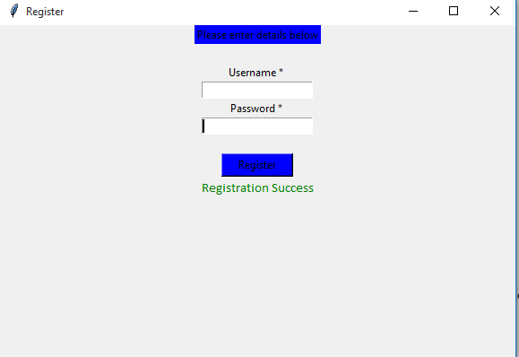

LOGIN WINDOW:- If user has an account then they can give its username and password to this window and can move to next phase.

LOGIN SUCCESSFUL:- When we give an username and password correct then other window will open to tell that login will be successfully happen.

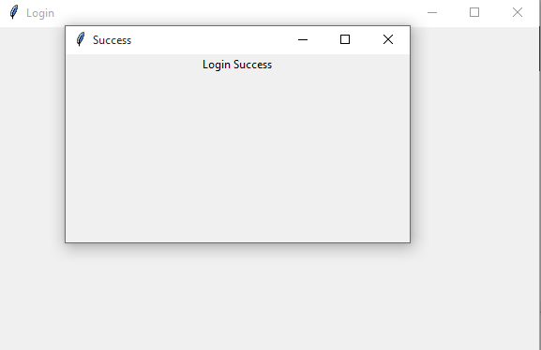

START WINDOW:- After registration or login, when we have an account then we can easily visit to this window.
Then one can start easily by clicking on START button.

SYMTOMS WINDOW:- After clicking on start button, then we can see in our screen some type of Question,which is called as Symtoms of an patient.
They will have to just click on button that is Yes or No.

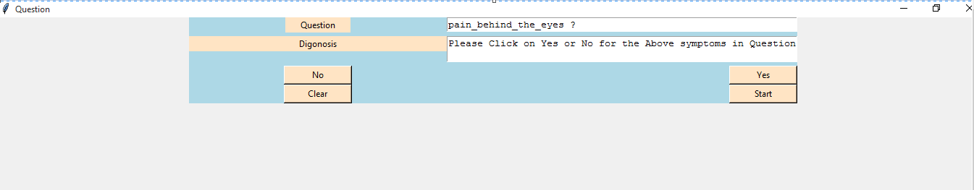

CLEAR WINDOW:- It will clear all the Question from the Screen.

CONSOLE BASED: In this, we have to write Yes or No only.
If our Symtoms are not matched then we have to write no in our screen.
When our Symtoms will be matched then we just have to write yes.

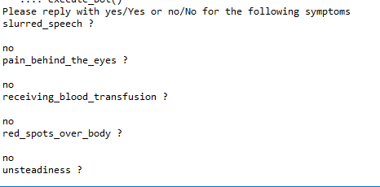

SYMPTOMS WINDOW:- When we write Yes on our console screen, then our matched problem will be found on screen. And it will also tell the Symptoms which may a patient have.

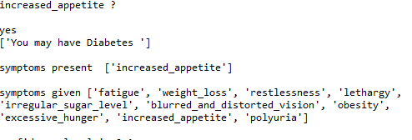

SUGGESTION BY MODEL:- After all this, Model will suggest the docter and also provide its link where one can easily visit with the help of chrome etc.

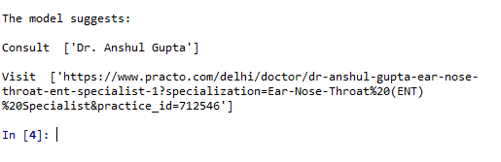

TESTING PHASE:

The basic goal of the software development process is to produce software that has no errors or very few errors. In an effort to detect errors soon after they are introduced, each phase ends with verification activity such as a review.
As testing is the last phase before the final software is delivered, it has the enormous responsibility of detecting any type of error that may in the software. A software typically undergoes changes even after it has been delivered. And to validate that a change has not affected some old functionality of software regression testing is performed
Levels Of Testing:
The basic levels of testing are unit testing, integration testing and system and acceptance testing. These different levels of testing attempt to detect different types of faults.
Code/Unit Testing:
Code testing and implementation is a critical process that can even consume more than sixty percent of the development time.
Testing:
The system development life cycle involves the phases of testing and debugging after the requirement analysis, designing and coding. The project in question was tested , debugged and implemented successfully.
Two strategies of software testing adopted for the new system are as follows:
Code testing
Specification testing

Code testing:
Code testing was carried out to see the correctness of the logic involved and the correctness of the modules. Tests were conducted based upon sample. All the modules are checked separately for assuming correctness and accuracy in all the calculations.

Specification testing:
It examines the specification stating about what program should do and how it performs under various conditions. This testing strategy is better strategy since it focuses on the way the software is expected to work.

Unit Testing:
During the phase of unit testing different constituent modules were testing against the specifications produced during the design for the modules. Unit testing is essentially for the verification of the code produced during the coding the phase, and goal is to test the internal logic of the modules. The modules once tested were then considered for integration and use by others.

Overview of Testing

1. Testing: Testing involves executing the program (or part of it) using sample data and inferring from the output whether the software performs correctly or not. This can be done either during module development (unit testing) or when several modules are combined (system testing).

2. Defect Testing: Defect testing is testing for situation where the program does not meet its functional specification. Performance testing tests a system's performance or reliability under realistic loads. This may go some way to ensuring that the program meets its non-functional requirements.

3.Debugging: Debugging is a cycle of detection, location, repair and test. Debugging is a hypothesis testing process. When a bug is detected, the tester must form a hypothesis about the cause and location of the bug. Further examination of the execution of the program (possible including many returns of it) will usually take place to confirm the hypothesis. If the hypothesis is demonstrated to be incorrect, a new hypothesis must be formed. Debugging tools that show the state of the program are useful for this, but inserting print statements is often the only approach. Experienced debuggers use their knowledge of common and/or obscure bugs to facilitate the hypothesis testing process. After fixing a bug, the system must be reset to ensure that the fix has worked and that no other bugs have been introduced. This is called regression testing. In principle, all tests should be performed again but this is often too expensive to do.

Test Planning:
Testing needs to be planned, to be cost and time effective. Planning is setting out standards for tests. Test plans set out the context in which individual engineers can place their own work. Typical test plan contains:
Overview of testing process
1. Requirements trace ability (to ensure that all requirements are tested)
2. List of item to be tested
3. Schedule
4. Recording procedures so that test results can be audited
5. Hardware and software requirements
6. Constraints

Overview of Testing Strategies:

Large systems are usually tested using a mixture of strategies. Different strategies may be needed for different parts of the system or stages of the process.

Top-down testing: This approach tests high levels of system before detailed components. This is appropriate when developing the system top-down and is likely to show up structural design errors early (and therefore cheaply). But this often has advantage that a limited, working system is available early on. Validation (as distinct from verification) can begin early. Its disadvantage is that stubs need to be generated (extra effort) and might be impracticable if component is complex (e.g. converting an array into a linked list; unrealistic to generate random list; therefore end up implementing unit anyway). Test output may be difficult to observe (needs creation of artificial environment). This is not appropriate for OO systems (except within a class).
Bottom-up testing: This is opposite of top-down testing. This tests low-level units then works up the hierarchy. Its advantages and disadvantages mirror those of top-down testing. In this testing there is need to write test drivers for each unit. These are as reusable as the unit itself. Combining top-down development with bottom-up testing means that all parts of system must be implemented before testing can begin, which does not accord with incremental approach discussed above. Bottom-up testing is less likely to reveal architectural faults early on. However, bottom-up testing of critical low-level components is almost always necessary. Appropriate for OO systems.

Stress testing: Tests system's ability to cope with a specified load (e.g. transactions per second). Tests should be planned to increase load incrementally. This type of testing goes beyond design limit until system fails (this test is particularly important for distributed systems like checking degradation of performance a s network traffic increases).

Back-to-back testing: Comparison of test results from different versions of the system (e.g. compare with prototype, previous version or different configuration). Process – Run first system, saving test case results. Run second system, again saving its results. Compare result files. The key point to be noted is that no difference does not mean no bugs. Both systems may have made the same mistake.

Defect testing: A successful defect test is a test that causes the system to behave incorrectly. Defect testing is not intended to show that a program meets its specification. If tests do not show up defects it may mean that the tests are not exhaustive enough. Exhaustive testing is not always practically applicable. Subset has to be defined (this should be part of the test plan, not left to the individual programmer).

IMPLEMENTATION:

Implementation is the stage in the project where the theoretical design is turned into the working system and is giving confidence to the new system for the users i.e. will work efficiently and effectively. It involves careful planning, investigation of the current system and its constraints on implementation, design of method to achieve the change over, an evaluation, of change over methods. A part from planning major task of preparing the implementation is education of users. The more complex system is implemented, the more involved will be the system analysis and design effort required just for implementation. An implementation coordinating committee based on policies of individual organization has been appointed. The implementation process begins with preparing a plan for the implementation for the system. According to this plan, the activities are to be carried out, discussions may regarding the equipment has to be acquired to implement the new system.

Implementation is the final and important phase. The most critical stage is in achieving a successful new system and in giving the users confidence that the new system will work and be effective. The system can be implemented only after thorough testing is done and if it found to working according to the specification. This method also offers the greatest security since the old system can take over if the errors are found or inability to handle certain types of transaction while using the new system.

The major elements of implementation plan are test plan, training plan, equipment installation plan, and a conversion plan.

ADVANTAGES:

- Better Efficiency in Delivering Services:
Project management provides a “roadmap” that is easily followed and leads to project completion. Once you know where to avoid the bumps and pots holes it stands to reason that you’re going to be working smarter and not harder and longer.

- Improved / Increased / Enhanced Customer Satisfaction:
Whenever you get a project done on time and under budget, the client walks away happy. And a happy client is one you’ll see again. Smart project management provides the tools that enable this client/manager relationship to continue.

- Enhanced Effectiveness in Delivering Services:
The same strategies that allowed you to successfully complete one project will serve you many times over.

- Improved Growth and Development Within your Team:
Positive results not only command respect but more often than not inspire your team to continue to look for ways to perform more efficiently.

- Greater Standing and Competitive Edge:
This is not only a good benefit of project management within the workplace but outside of it as well; word travels fast and there is nothing like superior performance to secure your place in the marketplace.

- Opportunities to Expand your Services:
A by-product of greater standing. Great performance leads to more opportunities to succeed.

- Better Flexibility:
Perhaps one of the greatest benefits of project management is that it allows for flexibility. Sure project management allows you to map out the strategy you want to take see your project completed. But the beauty of such organization is that if you discover a smarter direction to take, you can take it. For many small-to-midsize companies, this alone is worth the price of admission.

- Increased Risk Assessment:
When all the players are lined up and your strategy is in place potential risks will jump out and slap you in the face. And that’s the way it should be. Project management provides a red flag at the right time: before you start working on project completion.

- Increase in Quality:
Goes hand-in-hand with enhanced effectiveness.

- Increase in Quantity:
I saved the best for last> And increase in quality is often the result of better efficiency, a simple reminder regarding the benefits of project management.

MAINTENANCE:

Once the window application is launched, it enters the maintenance phase. All systems need maintenance. Maintenance is required because there are often some residual errors remaining in the system that must be removed as they are discovered. Maintenance involves understanding the effects of the change, making the changes to both the code and the documents, testing the new parts and retesting the old parts that were not changed. Maintenance is mainly of two types:
1. Corrective Maintenance
2. Adaptive Maintenance

Corrective Maintenance:
Almost all software that is developed has residual errors or bugs in them. Many of these surfaces only after the system have been in operation, sometimes for a long time. These errors once discovered need to be removed, leading to the software to be changed. This is called Corrective Maintenance.

Adaptive Maintenance:
Even without bugs, software frequently undergoes change. The software often must be upgraded and enhanced to include more features and provide more services. This requires modification of the software. This type of maintenance is known as the Adaptive Maintenance.

BIBLIOGRAPHY:

Books:-
- Learn PYTHON the HARD WAY(Third Edition)
- Introduction to Machine Learning
- Machine Learning with Python Cookbook

Website:
- www.we3schools.com
- www.stackoverflow.com
- www.it-ebooks.com

